|  |
| --- |
| Paul Good (20058208) IT Y1 W1 |
| Information Technology Systems |
| Buying a Laptop |

|  |
| --- |
| Paul Good  11/28/2012 |

Table of Contents

Laptops 2

Laptop 1 2

Dell 2

Laptops 3

Laptop 2 3

Toshiba 3

Laptops 4

Laptop 3 4

Custom 4

Picking Which Laptop 5

Accessories 6

# Laptops

## Laptop 1

### Dell

***System Specifications***

**Processor:** 1.8 GHZ Intel i3

**Operating System:** Windows 8 Standard edition 64Bit

**Hard Drive:** 500gb

**RAM:** 6gb

**Extras:** Microsoft Office Trial

**Source:** Dell.ie

**Price:** €619

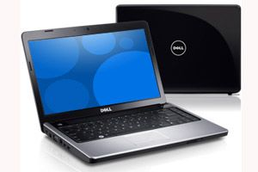

# Laptops

## Laptop 2

### Toshiba

***System Specifications***

**Processor:** 2.4 GHZ Intel i3

**Operating System:** Windows 7 Standard edition 64Bit

**Hard Drive:** 500gb

**RAM:** 4gb

**Extras:** 4 USB ports

Microsoft Office Trial

**Source:** Toshiba.ie

**Price:** €435

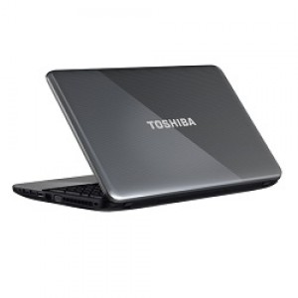

# Laptops

## Laptop 3

### Custom

***System Specifications***

**Processor:** 2.4 GHZ Intel i3 Dual Core

**Operating System:** Windows 8 Standard edition 64Bit

**Hard Drive:** 250gb

**RAM:** 2gb

**Extras:** 3 USB ports

Microsoft Office Trial

**Source:** pcspecialist.co.uk

**Price:** €578.11

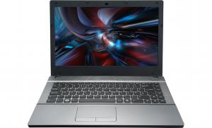

# Picking Which Laptop



I decided to pick the Toshiba as it by far the cheapest, has 4 GB ram which is sufficient for the tasks it would be used for. Also its 2.4GHZ processor would give it sufficient speed for multiple tasks. Although it has Windows 7 instead of 8, this doesn’t bother me as I am much more used to using Windows 7 rather than Windows 8. Its 500GB hard drive is also big enough as I do not require much storage other than for assignments which use very little memory. It seems like a practical computer and is perfect for college.

# Accessories

This would leave me with €265. With this I would buy Microsoft Office Pro for student for €100 on <http://software4students.ie/products/microsoft-office-2010-professional-plus?gclid=CKrQjKCn9LMCFY6K4Qod_ggAwg> and I could buy a laptop case for €70 from <http://www.justshop.ie/laptop-accessories-laptop-bags-c-664_711_712.html> .

